**Manage teams in the Microsoft Teams admin center**

* 03/08/2019
* 4 minutes to read
  + [all](https://github.com/MicrosoftDocs/OfficeDocs-SkypeForBusiness/blob/live/Teams/manage-teams-in-modern-portal.md" \o "all 9 contributors)
* Applies to:

Microsoft Teams

**Note**

Don't see this feature in your Microsoft Teams client yet? It's currently being rolled out and might not be available in your organization yet. See the [**Teams Roadmap**](https://aka.ms/TeamsRoadmap) for news about upcoming releases in Teams.

**Overview**

As an IT admin, you may need to view or update the teams that your organization has set up for collaboration, or you might need to perform remediation actions such as assigning owners for ownerless teams. You can manage the teams used in your organization through both the Microsoft Teams PowerShell module and the Microsoft Teams admin center. For full administration capabilities using these two toolsets, you should make sure that you are assigned one of the following roles:

* Global Administrator
* Teams Service Administrator

You should also make sure that your account has been assigned a non-trial Teams license for management. As part of a known issue, you should make sure that your account has only **one**admin role assigned. You can learn more about admin roles in Microsoft Teams in [Use Microsoft Teams admin roles to manage Teams](https://docs.microsoft.com/en-us/MicrosoftTeams/using-admin-roles), and you can read more about how to use the PowerShell cmdlets for managing teams in the [Microsoft Teams cmdlet reference](https://docs.microsoft.com/powershell/teams/?view=teams-ps).

This article provides an overview of the management tools for teams in the Microsoft Teams admin center.

**Teams overview grid**

Management tools for teams are under the **Teams** node in the Microsoft Teams admin center. (In the admin center, select **Teams** > **Manage teams**.) Each team is backed by an Office 365 group, and this node provides a view of groups that have been Microsoft Teams-enabled in your organization.

**Note**

We are in the process of backfilling previously created Teams to ensure that they will show up in this view.

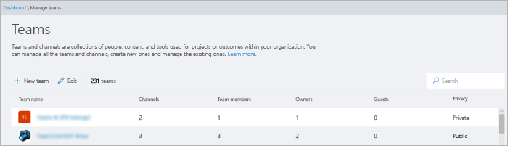

The grid displays the following properties:

* **Team name**
* **Channels** - a count of all channels in the team, including the default General channel.
* **Users** - a count of total users, including owners, guests, and members from your tenant.
* **Owners** - a count of owners for this team.
* **Guests** - a count of Azure Active Directory B2B guest users who are members of this team.
* **Privacy** - the AccessType of the backing Office 365 group.

**Search**

Search currently supports the string "Begins with" and searches the **Team name** field.

**Edit**

You can edit group and team-specific settings by selecting a team from the grid and then selecting the **Edit** button.

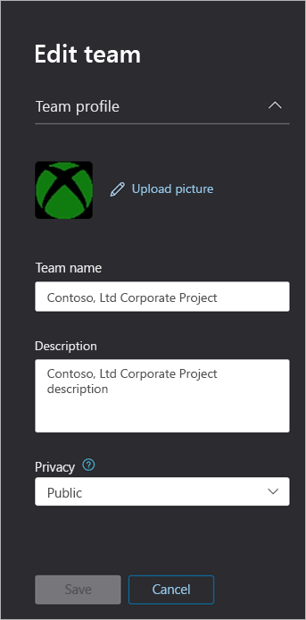

**Team profile**

You can navigate to the team profile page of any team from the main teams overview grid by clicking on the team name. The team profile page shows the members, owners, and guests that belong to the team (and its backing O365 Group), as well as the team’s channels and settings. From the team profile page, you can:

* Add or remove members and owners.
* Add or remove channels (Note that you cannot remove the General channel).
* Update team and group settings.

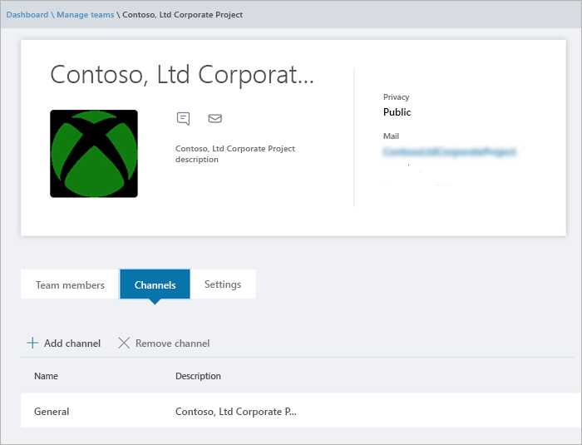

**Making changes to teams**

You can change the following elements of a team:

* **Users in the team** - you can add or remove members, and promote or demote owners
* **Channels** - you can add new channels or remove existing channels. You cannot delete the default "General" channel, and once created you can only edit channel name, not description.
* **Team name**
* **Team description**
* **Team privacy** - public or private
* **Team classification** - backed by your Office 365 group classifications
* **Team member settings** - select team member settings

The changes that you make to a team are logged. If you are modifying group settings (changing the name, description, photo, privacy, classification, or team members), these changes will be attributed to you through the audit pipeline. If you are performing actions against Teams-specific settings, your changes will be tracked and attributed to you in the general channel of the team.

**Troubleshooting**

**Issue: Teams missing from the Team Overview Grid**

When you enter the Microsoft Teams admin center, under the **Teams** option some of your teams are missing from the listing in the Teams Overview Grid.

**Cause**: This issue occurs when the team was incorrectly (or not yet) profiled by the system which can lead to a missing property for it to be recognized.

**Resolution: Manually set the property to the correct value via MS Graph**

Replace **{groupid}** in the Query for the actual GroupId in question, which you can get via the Exchange Online powershell, with the **"**[**Get-UnifiedGroup**](https://docs.microsoft.com/en-us/powershell/module/exchange/users-and-groups/get-unifiedgroup?view=exchange-ps)**"** cmdlet, as the "**ExternalDirectoryObjectId**" attribute.

1. Access [Graph Explorer](https://developer.microsoft.com/en-us/graph/graph-explorer)
2. Sign in to Graph Explorer on the left menu
3. Change the query line to: PATCH > v1.0 > [https://graph.microsoft.com/v1.0/groups/{groupid}](https://graph.microsoft.com/v1.0/groups/%7Bgroupid%7D)
4. Add the following value on the request body: {"resourceProvisioningOptions": ["Team"]}
5. Run the query on the top-right.
6. Confirm the team appears correctly in the Microsoft Teams admin center - Team Overview